Analysis of 16S rRNA genes to characterize microbial communities from sediments obtained from southern California wastewater-treatment discharge fields

Bacterial community structure using 16S rRNA from sediments obtained from offshore southern California wastewater-treatment discharge fields

Mar Pollution Bulletin

Authors: Stephanie D. Friedman ^{a *}, Katelyn Houghton ª and Marcus W. Beck ^{b}

Author affiliations:

ª US Environmental Protection Agency, 1 Sabine Island Drive, Gulf Breeze, FL, 32561, USA

^{b} Southern California Coastal Water Research Project (SCCWRP), 3535 Harbor Boulevard, Suite 110, Costa Mesa, CA, 92626, USA.

Corresponding author: * friedman.stephanie@epa.gov

ª Katelyn Houghton houghton.katelyn@epa.gov

^{b} Marcus W. Beck marcusb@sccwrp.org

Abstract (150 word max, has 147)

Some of the nation’s largest publicly owned wastewater-treatment plants are in southern California and serve as many as 4 million people. Treated sewage is discharged offshore into the Pacific Ocean through a network of outfalls. To study the effects of this effluent on the microbial population, 16S rRNA genes were sequenced from sediment collected along the outfall gradient from four southern California wastewater-treatment discharge plants. In addition, sediments were analyzed for chemical contaminants, nutrients and a benthic index. Bacterial and archaeal species were clustered into operational taxonomic units (OTU) using a 97% sequence similarity approach. Community structure and diversity were evaluated using multivariate statistical techniques. Firmicutes was the predominant bacteria phyla at most of the stations whereas Proteobacteria and Actinobacteria dominated the site closest to the outfall pipe in the Orange County sediment. Analysis of diversity suggest the bacteria populations were statistically different along the outfall gradient.

Keywords
16S rRNA gene; Microbial communities; Wastewater treatment; Sediments

1. Introduction

Marine and estuarine microbes are critical to the health of our environment and it is of utmost importance to maintain the natural balance of the microbial community. Many the nation’s largest publicly owned wastewater-treatment plants are in southern California and serve as many as 4 million people. In or near the Los Angeles area, treated sewage is discharged approximately 5-7 miles offshore into the Pacific Ocean through a network of outfalls. Long-term monitoring occurs inshore, shoreline and offshore for various parameters such as microbiological assessments, water-quality, fish, invertebrates, benthic fauna, sediment chemistry and kelp beds. However, little is known about the influence of wastewater effluent on microbial communities harbored within the sediment of the effluent outfall (REFERENCES). To evaluate whether the microbial community was altered, DNA was extracted and sequenced from sediment collected along the outfall gradient from the following four municipalities; Los Angeles County (Joint Water Pollution Control Plant), City of Los Angeles (Hyperion Plant), City of San Diego and from Orange County.. The research objective was to inventory complex microbial communities and to identify key microbial taxa that attributed to community variation and/or community uniqueness among and within the wastewater- treatment discharge fields.

Sequencing the 16S rRNA gene is a rapid and feasible approach to characterize microbial communities (Sogin et al., 2006). The highly conserved 16S rRNA gene in bacteria and archaea has sufficient variability to distinguish the taxonomic composition down to the individual species or to the Operational Taxonomic Units (OTUs). The OTU is a means to characterize the 16S rRNA gene sequence based on sequence similarity as an OTU cluster is 97% sequence identity at the genus level whereas 98% or 99% is the threshold suggested for species separation. This project applies 16S rRNA gene sequencing to examine sediment microbial communities, bioinformatics and statistical methods that can be applicable to other locations with similar data.

2. Materials and methods

2.1 Sediment collection

As part of an on-going monitoring program by the Southern California Coastal Water Research Project (SCCWRP), 14 sediments were collected along gradients from the outfall pipes from four southern California wastewater-treatment discharge fields as follows: i) Los Angeles County, ii) City of Los Angeles, iii) San Diego, and iv) Orange County (Fig 1). In addition, sediment chemistry metadata was obtained by SCCWRP. At each station, two replicate cores were taken from a Van Veen grab. Core tubes were used to extract 5-cm of sediment from the grab. Samples were placed in a 1-quart bag in a cooler with dry ice and transferred to a -80˚ C freezer at the lab until processed.

Table 1. Site locations for sediment collection. Each station was grouped by nearest governing municipality and further grouped by relative location from the outflow pipe of the nearest wastewater-treatment plant. (AT THE END OF THIS DOCUMENT)

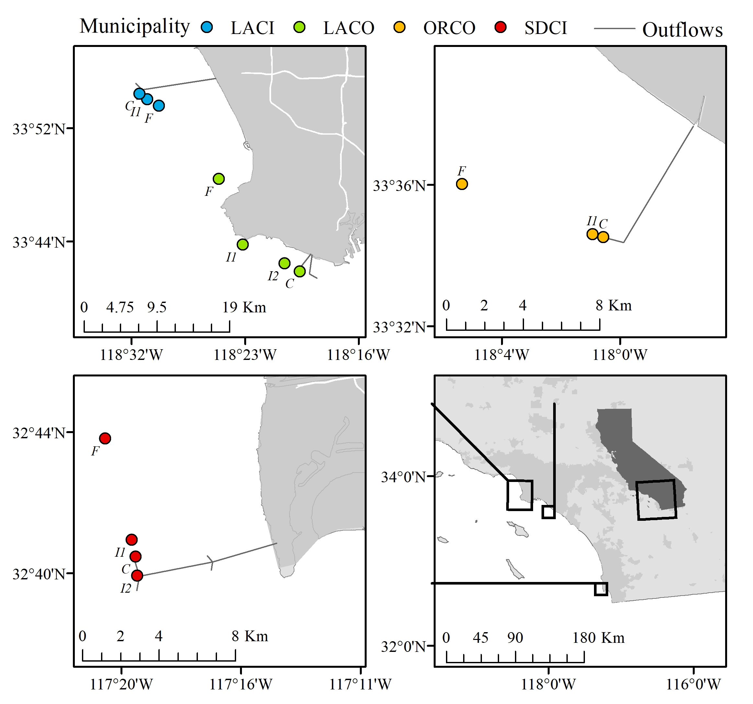

Figure 1. Sediment sample stations from the wastewater-treatment discharge fields along the southern California coast according to their GPS coordinates. Stations are diagramed by their respective municipality. See Table 1 for a detailed description of station metadata. Text designations next to each site indicate relative categories for distance from each outflow pipe (C = close, I1, I2 = intermediate, F = far)

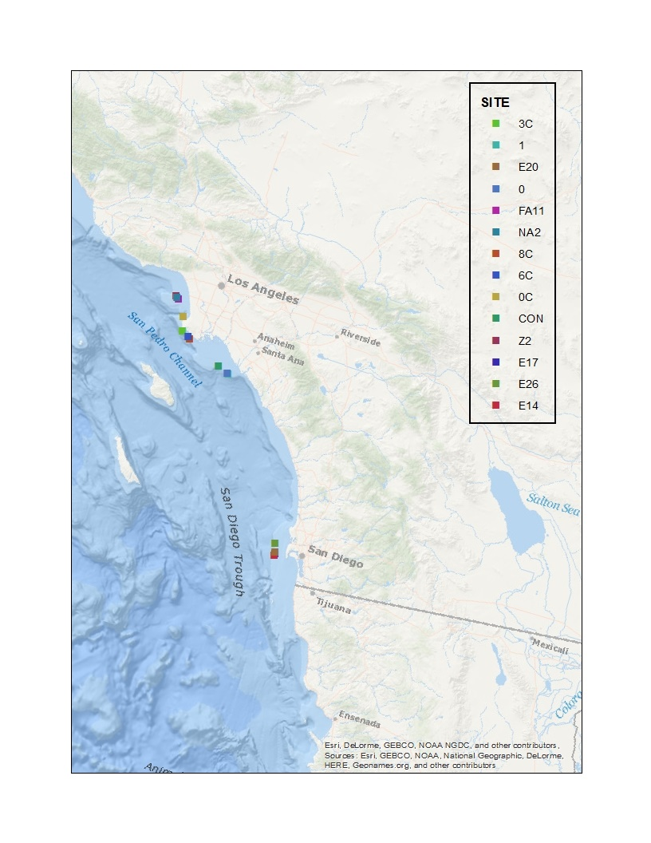
Map by Elizabeth Paulukonis (may or may not use this one)

2.2 DNA extraction, PCR and sequencing

DNA was extracted from each sediment sample using a Power Soil DNA kit (Mo Bio Laboratories, Carlsbad, CA) and subsequently cleaned with a DNA Clean and Concentrator kit (Zymo Research, Irvine, CA). All DNA samples were sent to Argonne National Laboratory for Mi-Seq (Illumina, San Diego, CA) paired-end sequencing of the 16S rRNA gene. Primers targeting the V4 region of the 16S rRNA region designed to detect both Bacteria and Archaea are described in Caporaso et al., and Apprill et al., 2015, and were selected due their frequency of use in research as this primer set has been shown to generate the most accurate results even when tested on a variety of platforms (Fouhy et al., 2016). To minimize amplification and sequencing bias (reference that IDT info) primers used for sequencing were modified and barcoded for Illumina Mi-Seq platorm as follows. The forward primer 515fB was constructed by i) 5’ Illumina adapter, ii) GoLay barcode iii) forward primer pad, iv) forward primer linker and v) forward primer (515fB) with the following sequence:
5’ AATGATACGGCGACCACCGAGATCTACACGCT XXXXXXXXXXXX TATGGTAATT GT GTGYCAGCMGCCGCGGTAA 3’
The reverser primer 806rB was modified by i) reverse compliment of 3’ Illumina adapter, ii) reverse primer pad iii) reverse primer linker and iv) reverse primer (806rB) resulting in the following sequence:
5’ CAAGCAGAAGACGGCATACGAGAT AGTCAGTCAG CC GGACTACNVGGGTWTCTAAT 3’

2.3 DNA Sequence Analysis

The resulting 16S rRNA sequences were processed using mothur version 1.39.5 (Schloss et al., 2016) following the mothur MiSeq protocol (accessed 6/12/17). Contigs were assembled using the forward and reverse sequences with an average sequence length of 254 bp. Sequences were aligned to and classified with the Silva database v128 and any sequences not aligning to the desired region were screened and removed. Any sequences classified as Chloroplast, Mitochondria, unknown, or Eukaryota were also removed. Chimeras were removed using uchime by Robert C. Edgar (http;//drive5.com/uchime). Sequences were clustered into Operational Taxonomic Units (OTUs) based on 97% nucleotide sequence identity. Each sample was sub-sampled to 27,499 sequences/sample to normalize the data and account for differences in sampling effort/intensity between samples. Error rates for each sequence run were assessed using the BEI Mock Communities, 0.00013971 (0.01%)

2.4 Statistical analysis

The abundance and taxonomy data at the OTU level were analyzed using the multivariate statistics package, Primer v7 (Primer-E, UK). Data were first log(x+1) transformed to down weight the contributions of the most dominant taxa and Bray-Curtis similarity values were calculated from the transformed data. A non-parametric permutation test on the similarity values was run to test the effects of location and position from the outfall (ANOSIM). OTU level hierarchical agglomerative clustering was based on the Bray-Curtis dissimilarity matrix of abundance data using the group average linkage calculations and the SIMPROF test option. The SIMPROF test option tests the null hypothesis that there is no evidence of multivariate structure. SIMPER analysis (similarity percentages) was used on OTU level data to determine species contribution to within-group similarity and between-group dissimilarity.

Alpha diversity. Alpha diversity (Fisher et al. 1943) was estimated at the genus-level for each sampling site. Differences in diversity between sites were evaluated using a simple analysis of variance (ANOVA) to test for a main effect of distance from the wastewater outflow pipes or by municipality. Diversity estimates were grouped by distance categories across the municipalities for the first analysis. Similarly, diversity estimates were grouped by municipality across the distance categories for the second analysis. Assumptions for ANOVA were verified using Bartlett’s test of equal variances between groups with the diversity data and Shapiro-Wilk test of normality of the residuals from the model output (R Core Team 2017).

3. Results

3.1 Sediment chemistry DID WE DECIDE TO KEEP THE METADATA INFO AND IF SO, IN WHAT FORMAT? Or maybe keep some of the data if we can get a good “table 3” like the Campbell paper; Katelyn is working on this

NEED PLOTS OF SEDIMENT RESULTS OR OMIT THIS COMPLETELY, EVEN IN THE ABSTRACT?

Fig 2. Environmental metadata for Los Angeles County wastewater-treatment sediments. (DELETED THIS METADATA; MAY NEED TO RE-NUMBER THE FIGURES

3.2 Microbial communities and statistical analyses

16S rRNA microbial community analysis. A total of 14 sediment samples were collected as part of an on-going SCCWRP monitoring program. DNA sequenced on the Illumina Mi-Seq platform resulted in 1,095,155 contigs assembled using the forward and reserve sequences which reduced to XXXX sequences after screening and chimera removal. Operational Taxonomic Units (OTUs) based on 97% nucleotide sequence identity resulted in a total of 564,711 sequences. The number of OTUs from all samples ranged from XXX to XXX with a total of XXX OTUs generated with the Silva database. Error rates for each sequence run were determined using the BEI Mock Communities (REFERENCE; BEI Resources, Manassas, VA).

Alpha diversity. Results from ANOVA tests indicated that alpha diversity estimated at each site was significantly different between distance categories from outflow pipes (Table 2, F = 8.6, df = 2, 11, p < 0.01). Diversity was highest closest to the outflow and declined with increasing distance. Over half (adjusted R² of 54%) of the variation in diversity was explained by distance from the outflows. There were no significant differences in diversity between municipalities.

Abundant taxa. When examining the top fifty abundant bacteria for all municipalities, phylum Firmicutes was the dominant bacteria (95%) across all municipalities and distance-from-the-pipe except for Orange County (Fig 3B, Fig 4 Bacteria). Orange County “far” and “intermediate” from the pipe were dominated by Firmicutes, however the pipe station “close” were dominated by the phyla Actinobacteria (1.4%), Proteobacteria (1.1%), Chloroflexi (1%) and Planctomycetes (1%) and Bacteroidetes (%? How did I calculate these????). KATELYN WILL CALCULATE THESE AND WIL DETERMINE WHICH SAMPLES CONTRIBUTED MOST TO “CLOSE, FAR, INTERMEDIATE.”

The archaeal community was mainly composed of the phylum Lokiarchaeota (32%) with the highest abundance of 11% at LACO “close.” Only five archaeal phyla were identified, Lokiarchaeota (32%), Thaumarchaeota (15%), Woesearchaeota_DHVEG-6 (25.5%), Euryarchaeota (10%), Bathyarchaeota (12%) plus an Archaea unclassified phylum (3.6%). Phylum Euryarchaeota occurred only at the Los Angeles stations. All three stations at LACI contained the archaea phylum Euryarchaeota and this was the only municipality to have the genus Methanothermobacter (order Methanobacteriales). LACO “close” was the only other station with phylum Euryarchaeota and the only station to have the order Thermoplasmatales.

Station/Site clustering showed the greatest divergence for bacteria ORCO “close” whereas the Archaea, although not statistically significant, showed the greatest divergence at LACI “far” (Fig 4). Results were statistically significant regarding abundance of bacteria by their location to the outfall pipe with “far” being statistically significant (Fig 3A and Table 2) whereas abundance by each individual municipality was not significant. The most abundant genera in the significant “far” from pipe discharge were Clostridiaceae, Tepidibacter, Bacillaceae and Peptostreptococcaceae (Fig 3A).

USE THIS INFO IN THE DISCUSSION

Fig 3. Bacteria abundance by genera from sediment collected from off-shore wastewater-treatment plant discharge stations along the southern California coast. Abundance Bacteria genera analyzed as distance from the outfall pipe.

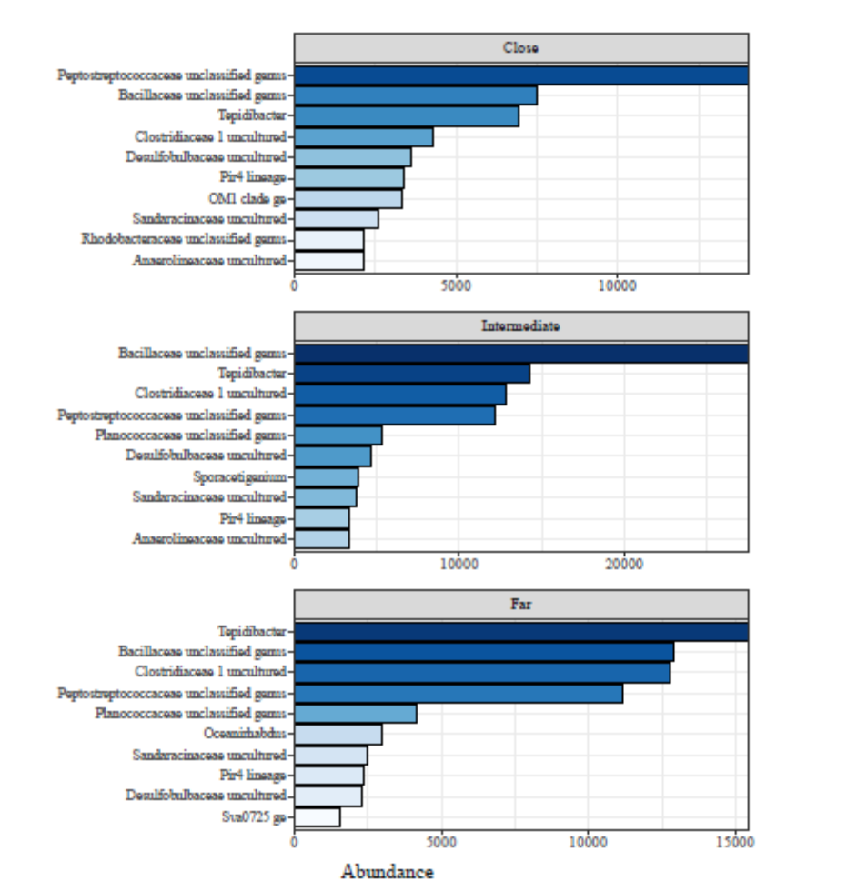

RE-DO BASED ON 100% AND NOT ON COUNTS

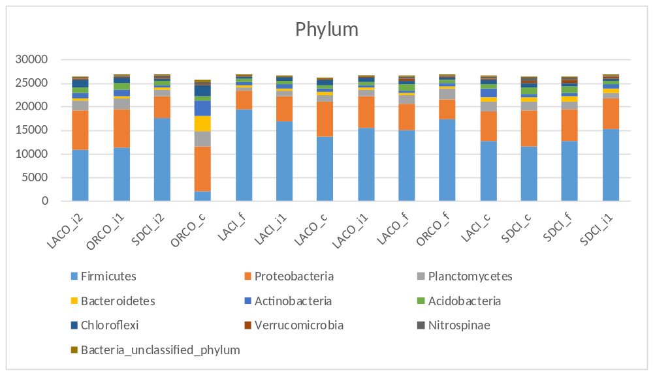

Table 2. Summary of analysis of variance results for community diversity with distance from outflow. Diversity measures were based on Fisher’s Alpha (Fisher et al.., 1943) using abundance of genera at each site. The model intercept is the average diversity estimate (standard error in parentheses) at all close sites and the remaining parameter estimates (intermediate and farthest) are referenced accordingly.
 | Models
Constant (close) | 88.68∗∗∗
 | (3.88)
Intermediate | −14.72∗∗
 | (5.01)
Farthest | −22.30∗∗∗
 | (5.48)
Observations | 14
R2 | 0.61
Adjusted R2 | 0.54
Residual Std. Error (df = 11) | 7.75
F Statistic (df = 2; 11) | 8.63∗∗∗
Note: ∗∗p<0.05; ∗∗∗p<0.01

Fig 4. OTU level non-metric multidimensional scaling plot of the Bray-Curtis similarity values from abundance data (Primer v7) with overlays of trajectories for distance from outfall. Abundance data were log(X+1) transformed prior to analysis. Colors indicate municipality and subscripts indicate distance categories from an outflow pipe at each site (“F” is farthest, “C” is closest, “I” is intermediate). LACI is City of Los Angeles; SDCI is City of San Diego, LACO is Los Angeles County and ORCO is Orange County, CA.

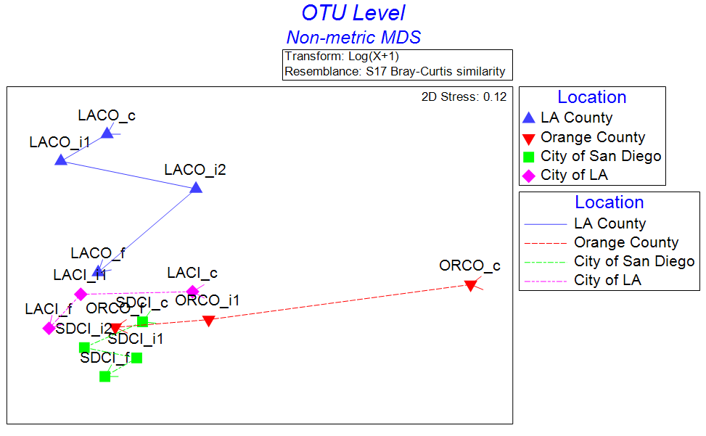

Table 3. ANOSIM (Primer v7), analysis of similarities, to test the hypothesis for difference in community structure between groups (location vs distance from outfall) using a permutation method on a Bray-Curtis resemblance matrix of Log(X+1) transformed OTU level data. Tests for differences between unordered Location groups had a sample statistic (R): 0.431 and a significance level of sample statistic: 0.2%. Tests for differences between the location from the outfall pipe (i.e., close, intermediate, far) groups had a Sample statistic (Average R): 0.542 and a significance level of sample statistic: 6.4% and thus very close to the p <0.05 statistical significance value.

 | R | Significance | Possible | Actual | Number >=
Groups | Statistic | Level % | Permutations | Permutations | Observed
LA County, Orange County | 0.37 | 5.7 | 35 | 35 | 2
LA County, City of San Diego | 0.729 | 2.9 | 35 | 35 | 1
LA County, City of LA | 0.611 | 5.7 | 35 | 35 | 2
Orange County, City San Diego | 0.556 | 2.9 | 35 | 35 | 1
Orange County, City of LA | 0.111 | 40 | 10 | 10 | 4
City of San Diego, City of LA | 0.722 | 2.9 | 35 | 35 | 1

The two-way nested ANOSIM (Table 3) highlights the trend as demonstrated in the MDS plot (Fig 5). The test for differences between wastewater-treatment and outfall location groups came back significant at p < 0.002 (Table 3) and a sample stat value (R) 0.431. If the R value was 1 it would mean the locations were completely different from one another. If the R value was 0 it would mean there is no distinguishable difference between the groups. The R from this test (0.431) showed there are some large differences and that they were highly significant as observed in the MDS plot (Fig 5), as the samples from one location are all close to the other samples from that same location. When you consider the test for difference between position from outfall groups, the sample statistic is higher at 0.542, but was just on the verge of being significant with p < 0.064 (Table 3) suggesting the location (close, intermediate, far) of the station from the outfall pipe lends evidence to the shift in the microbial community.

CAN WE ANALYZE THE TOP 5 OR 10 TAXONOMY TO A FEW OF THE METADATA (AS IN THE CAMPBELL PAPER?); Katelyn is doing this

4. Conclusion/discussion

CAN WE SHOW COMMUNITIE CHANGES IN RESPONSE TO THE POLLUTION GRADIENT? WHAT ARE THE DOMINANT COMMUNITIES BACT AND ARCHAEA AT THE DISCHARGE SITE? DO THESE CHANGE AWAY FROM THE DISCHARGE SITE?

Microbial communities based on 16S rRNA gene V4 sequencing data for bacteria and archaea were compared across four municipalities, City of Los Angeles (LACI), City of San Diego (SDCI), Los Angeles County (LACO) and Orange County (ORCO) in southern California. Statistical significant differences were observed based on the distance from the pipe outfall for bacteria but not for archaea. The most abundant bacteria genera in the “far” from pipe discharge were Clostridiaceae, Tepidibacter, Bacillaceae and Peptostreptococcaceae and were statistically significant (p<0.01; Table 2) when compared to “intermediate” and “close.”

Overall, the most abundant bacteria were phyla Firmicutes (10,820-19,473 reads) followed by phyla Proteobacteria (3587-9516 reads). When examining the top fifty abundant bacteria, phyla Firmicutes was the dominant bacteria across all municipalities and distance-from-the-pipe except for Orange County (Fig 3B, Fig 4 Bacteria). Orange County “far” and “intermediate” from the pipe were dominated by Firmicutes, however Firmicutes was miniscule (1933 reads) from the “close” outfall pipe station but instead, this location was dominated by the phyla Proteobacteria (9516 reads), Actinobacteria (3271 reads), Planctomycetes (3330 reads), Bacteroidetes (3197 reads) and Chloroflexi (2354 reads). Proteobacteria were found to be the dominant phylum at wastewater-treatment outfalls in two studies in China (Zhang et al., 2016; Zhang et al., 2014) whereas Bacteroidetes was high in abundance at the outfall stations in southeast Florida (Campbell et al., 2015). Fecal-polluted sites were dominated by Proteobacteria, Firmicutes, Actinobacteria, Bacteroides and Spirochaetes in an urban Santa Ana River watershed in southern California (Ibekwe et al., 2016) with Proteobacteria dominating their samples. Vierheilig et al., 2015, noted that fecal communities collected from a broad range of animals were dominated by Firmicutes, Bacteroidetes and Proteobacteria and were more similar to their freshwater basin-catchment study site water and sediment samples that had a high abundance of Proteobacteria and Bacteroidetes whereas the nearby soil were dominated by Proteobacteria and Actinobacteria.

WERE THE BACTEROIDES HIGHER AT EACH OUTFALL STATION AS COMPARED TO THOSE FARTHER FROM THE OUTFALL?? CAMPBELL PAPER PG 397 DISCUSSES THIS

Reportedly, Actinobacteria are widely distributed in marine habitats (Stach et al, 2003), however this phylum was most abundant at Orange County treatment plant “close” sediment station (3271 reads) when compared to the other treatment-plant stations (476-1794 reads). Chen et al (2016) noted the Actinobacteria were significantly correlated to pH, total organic carbon and other geochemical factors rather than to special distributions in deep-sea sediments from the Southwest Indian Ridge. These findings may corroborate and support the evidence of the Actinobacteria being the fourth to fifth most abundant phyla at the wastewater outfall stations in this study.

The most abundant Archaea was phylum Lokiarchaeota with the highest abundance being at LACO “close.” LACI had the most abundant Methanothermobacter and in addition, this was the only municipality to contain this genus. TO CONTINUE

PUT IN RESULTS??
The physical geographic location along the southern California coast, i.e., Los Angeles, vs San Diego vs Orange County, or the depth of the sediment samples (56m-98m) did not appear to influence the microbial community composition whereas the proximity to the outfall pipe demonstrated a trend (Fig 5). The samples closest to the wastewater-treatment outfall pipe diverged on the plot. However, as the samples were more and more distant from the outfall they converged together to their “normal” state as demonstrated by the MDS plot at the OTU level (Fig 5). The microbial community in the Orange County “close” to the outfall pipe showed the greatest divergence when compared to the other stations. Although the MDS plot demonstrates a trend in the shift in the microbial community at the OTU level, it appears that the samples closest to the pipes were affected by geochemical changes and not due to spatial variations Another study showed consistent shifts in microbial community diversity in response to a nitrogen pollution gradient (Xiong et al., 2014), START HERE AND CITE PAPERS THAT SUPPORT THIS FINDING

In summary, the application of next-generation sequencing demonstrated an altered or shift in microbial communities in response to land-based influences such as paper mills (Guo et al., 2016), wastewater outfall ( that coral Satay Sadowsky 2017 and other papers ) and ???.

Disclosures: Conflicts of interest: none. All authors have approved the final article.

EPA disclosure statement?

ACKNOWLEDGEMENTS: Erik Pilgrim, EPA, David Gillett at SSCWRP, Anne for GIS analysis;

REFERENCES

Apprill A, McNally S, Parsons R, Weber L. 2015. Minor revision to V4 region of SSU rRNA 806R gene primer greatly increases detection of SAR11 bacterioplankton. Aquatic Microbial Ecology. 75:129-137.

Campbell, A.M., J. Fleisher, C. Dinigalliano, J.R White and J.V. Lopez. 2015. Dynamics of marine bacterial community diversity of the coastal waters of the reefs, inlets, and wastewater outfalls of southeast Florida. Microbiol Open, 4(3):390-408.

Caporaso JG., Lauber CL., Walters WA., Berg-Lyons D., Lozupone CA, Turnbaugh PJ, Fierer N., and Knight R. 2011. Global patterns of 16S rRNA diversity at a depth of millions of sequences per sample. PNAS. 108(1):4516-4522. DID I CITE THIS?

Caporaso JG, Lauber CL, Walters WA, Berg-Lyons D, Huntley J, Fierer N, Owens SM, Betley J, Fraser L, Bauer M, Gormley N, Gilbert JA, Smith G, Knight R. 2012. Ultra-high-throughput microbial community analysis on the Illumina HiSeq and MiSeq platforms. ISME J.

Fisher, R.A., Corbet, A.S. & Williams, C.B. 1943. The relation between the number of species and the number of individuals in a random sample of an animal population. Journal of Animal Ecology 12, 42–58.

Fouhy, F., Clooney, A.G., Stanton, C., Claesson, M.J., and Cotter, P.D. 2016. 16S rRNA gene sequencing of mock microbial populations- impact of DNA extraction method, primer choice and sequencing platform. BMC Microbiol, 16:123-135.

Guo, J., Zhao, L., Lu, W., Jia, H., and Sun, Y. 2016. Bacterial communities in water and sediment shaped by paper mill pollution and indicated bacterial taxa in sediment in Daling River. Ecol Indicators 60:766-773.

Huse, S.M., D.B Mark Welch, A. Voorhis, A. Shipunova, H.G, Morrison, A.M. Eren, and M.L. Sogin. 2014. VAMPS: a website for visualization and analysis of microbial population structures. BMC Bioinformatics 15:41. DO I NEED THIS?

Ibekwe et al., 2016

James E. M. Stach, Luis A. Maldonado, Alan C. Ward, Michael Goodfellow and Alan T. Bull. 2003. New primers for the class Actinobacteria: application to marine and terrestrial environments. Environmental Microbiol 5(10): 828–84.

Klindworth et al., 2013.

Lyon, G.S. and M.A. Sutula. 2011. Effluent discharges to the Southern California Bight from large municipal wastewater treatment facilities from 2005 to 2009 [Internet]. SCCWRP Annual Report 2011. Costa Mesa (CA): Southern California
Coastal Water Research Project. Available from http://ftp.sccwrp.org/pub/download/
DOCUMENTS/AnnualReports/2011AnnualReport/ar11_223_
236.pdf

Ping Chen, Limin Zhang, Xiaoxuan Guo, Xin Dai, Li Liu, Lijun Zi, Jian Wang, Lei Song, Yuezhu Wang, Yaxin Zhu, Li Huang and Ying Huang. 2016. Diversity, Biogeography, and Biodegradation Potential of Actinobacteria in the Deep-Sea Sediments along the Southwest Indian Ridge. Front. Microbiol., 29 August 2016. NEED PAGE, VOLUME

R Core Team (2017). R: A language and environment for statistical computing, v3.4.3. R Foundation for Statistical Computing, Vienna, Austria. URL https://www.R-project.org/.

Rosen, G.L., E.R. Reichenberger and A.M. Rosenfield. 2011. NBC: The Naïve classification tool webserver for taxonomic classification of metagenomic reads. Bioinformatics 27 (1):127-129.

Sogin, M.L., H.G. Morrison, J.A. Huber, D.M. Welch, S.M. Huse, R.R. Neal, J.M. Arrieta, G.J. Herndl. 2006. Microbial diversity in the deep sea and the underexplored “rare biosphere.” Proc Natl Acad Sci USA, 103:12115-12120.

Vierheilig, J., Savio, D., Ley, R.E., Mach, R.L., Farnleitner, A.H., and Reischer, G.H. 2015. Potential applications of next generation DNA sequencing of 16S rRNA gene amplicons in microbial water quality monitoring. Water Sci Technol. 72(11):1962-1972.

Wang, Z.H., J.Q. Yang, D.J. Zhang, J. Zhou, C.D. Zhang, X.R. Su and T.W. Li. 2014. Composition and structure of microbial communities associated with different domestic sewage outfalls. Genetics Molecular Res, 13(3):7542-7552.

Yan Zhang, Lujun Chen, Renhua Sun, Tianjiao Dai, Jinping Tian, Rui Liu and Donghui Wen. Effect of wastewater disposal on the bacterial and archaeal community of sea sediment in an industrial area in China. 2014. FEMS Microbiol Ecol 2014) PAGE, VOLUME?

Yan Zhang, Lujun Chen, Renhua Sun, Tianjiao Dai , Jinping Tian , Wei Zheng , Donghui Wen, 2016. Journal of Env Sciences 44:57-68.

Table 1. Site locations for sediment collection. Each station was grouped by nearest governing municipality and further grouped by relative location from the outflow pipe of the nearest wastewater-treatment plant.

Waste-Water Treatment Plant | Abbreviation | Station ID | Station Depth (m) | Distance from  outfall pipe | Distance from  outfall pipe (m) | Latitude, longitude
City of Los Angeles | LACI_{c} | Z2 | 59 | close | 0 | 33.9075; -118.52445
 | LACI_{i1} | NA2 | 57 | intermediate₁ | 1256.5 | 33.9009; -118.515116
 | LACI_{f} | FA11 | 56 | far | 2918.7 | 33.89323; -118.50175
City of San Diego | SDCI_{c} | E17 | 98 | close | 0 | 32.6746667; -117.32567
 | SDCI_{i1} | E14 | 98 | intermediate₁ | 1106.1 | 32.6656667; -117.32483
 | SDCI_{i2} | E20 | 98 | intermediate₂ | 1005.4 | 32.6826667; -117.32783
 | SDCI_{f} | E26 | 98 | far | 7048 | 32.730333; -117.34283
Orange County | ORCO_{c} | 0 | 59 | close | 0 | 33.57762; -118.01613
 | ORCO_{i1} | 1 | 56 | intermediate₁ | 656.3 | 33.57622; -118.00997
 | ORCO_{f} | CON | 56 | far | 8082.7 | 33.60062; -118.08978
Los Angeles County | LACO_{c} | 8C | 61 | close | 0 | 33.6985; -118.336
 | LACO_{i1} | 6C | 61 | intermediate₁ | 2176.4 | 33.7078; -118.354
 | LACO_{i2} | 3C | 61 | intermediate₂ | 7906.6 | 33.73; -118.403
 | LACO_{f} | 0C | 61 | far | 16565 | 33.8072; -118.431

